Python Uninstall

First uninstall Python if you have already installed it.

To uninstall Python do the following steps.

1. Uninstalling Python

Windows:
- Open the Control Panel.
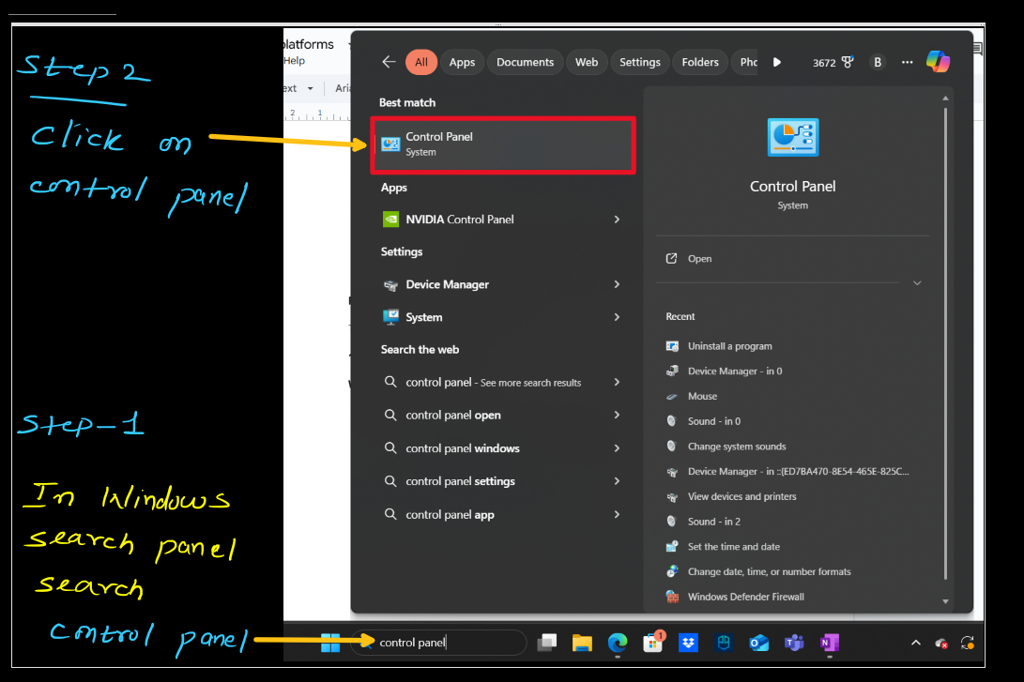

- Navigate to Programs > Programs and Features.
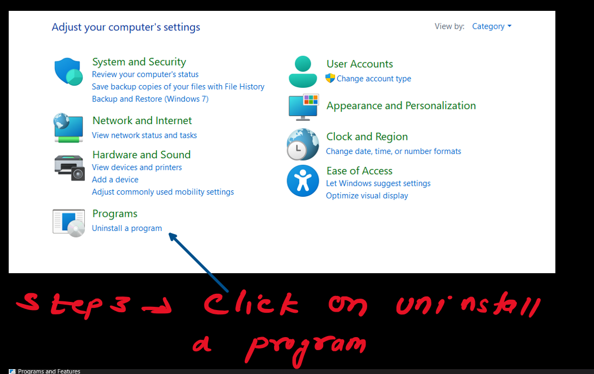
- Select it and click Uninstall.
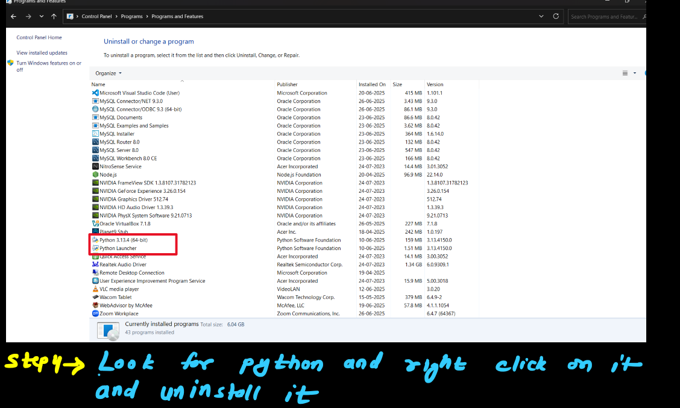
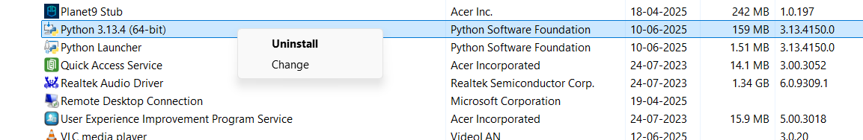

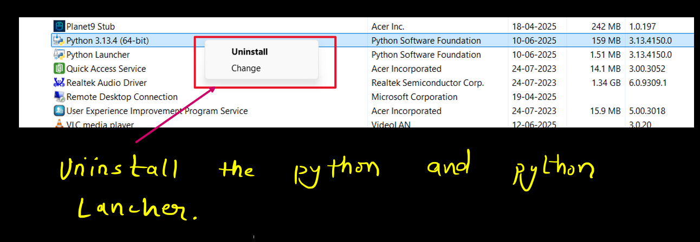

Python Install

Video Link to install Python : https://youtu.be/fS1Lh5TwWN8?si=_pJSSUKGiRa1bN3E

Note : (the version might be different so you have to install latest version)

OR

Install Python By this Below mentioned Method

- Download Python3.13.X setup from Download Python | Python.org
- Look For the Python Setup file in Download and double click on it.
- If prompted press ok
- Select add Python to path in file.

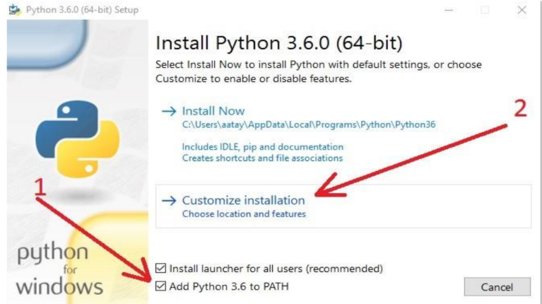
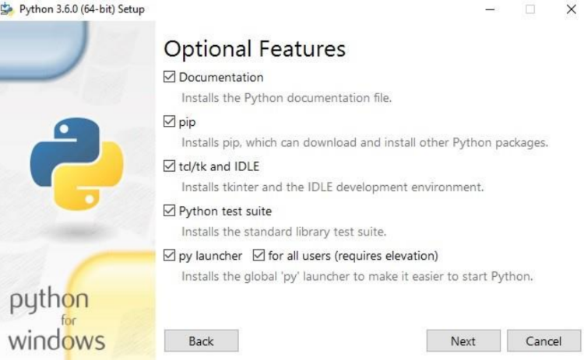

- Add Python For all User and Change Folder path to C:\Python
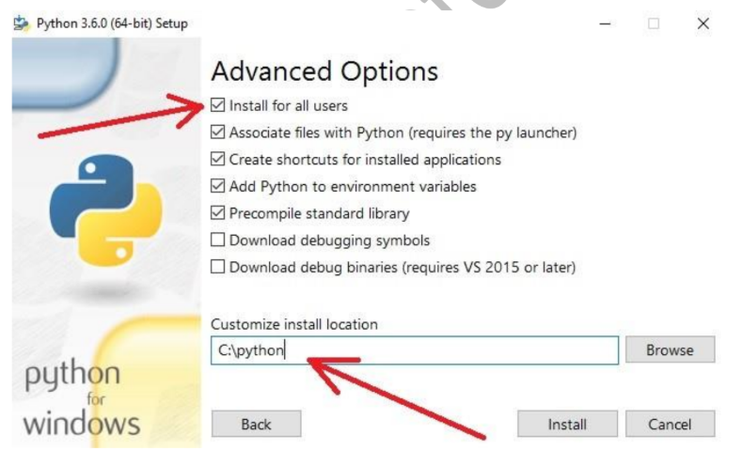

- Disable Path length limit

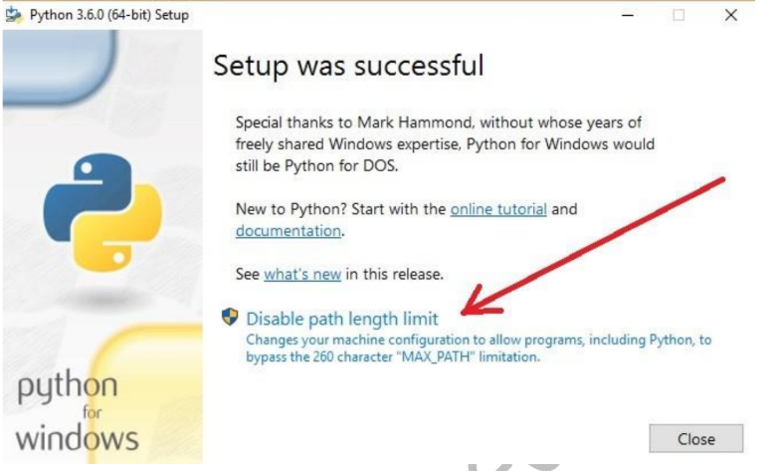

- In the windows search panel open command prompt and insert below command to make sure that python is installed properly .
python — version

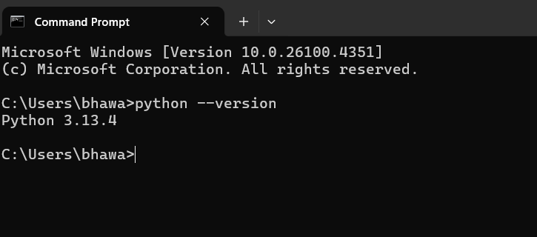

- Then press another command that if pip (python package installer) is installed properly.

pip list

After inserting this command if there is not any error then python is installed properly.

Install Jupyter Notebook
- Install python first if not installed already.
- Head Over Command Prompt and write the following command there.

pip install jupyter notebook

- Create a new folder named Python Learning at your convenience location.
- Open command from there and then insert the following command to open jupyter notebook from command prompt.

jupyter notebook

- If the above command doesn't work then try this command.

python -m jupyter notebook

- Jupyter notebook will open in your default browser (generally edge of chrome)

Some Jupyter Essential Shortcuts

Mode Switching

Mode | Shortcut | Action
Command | Esc | Switch to Command mode (gray border)
Edit | Enter | Switch to Edit mode (green border)

Edit Mode (Inside a Cell)

Shortcut | Action
Ctrl + Enter | Run current cell
Shift + Enter | Run cell and move to next
Alt + Enter | Run cell and insert new below
Ctrl + Shift + - | Split cell at cursor
Tab | Code completion
Shift + Tab | Tooltip (docstring/help)
Ctrl + / | Toggle comment

Command Mode (Cell-level Operations)

Shortcut | Action
A | Insert cell Above
B | Insert cell Below
X | Cut selected cell
C | Copy selected cell
V | Paste cell Below
Shift + V | Paste cell Above
D D | Delete cell
Z | Undo delete
M | Convert to Markdown
Y | Convert to Code
R | Convert to Raw
L | Toggle line numbers
O | Toggle output
Shift + O | Toggle output scrolling
Up / Down | Navigate between cells
Shift + ↑ / ↓ | Select multiple cells

Notebook Actions

Shortcut | Action
Ctrl + S | Save notebook
Ctrl + Shift + P | Open command palette
H | Show all shortcuts
P | Open command palette (alternative)

Kernel & Cell Execution

Shortcut | Action
0 0 | Restart kernel
I I | Interrupt kernel
Shift + Enter | Run cell, go to next
Ctrl + Enter | Run cell, stay
Alt + Enter | Run cell, insert new

Markdown (Edit Mode)

Syntax | Output
# Heading | <h1>
**bold** | bold
*italic* | italic
`code` | code
- item | item (list)
[text](url) | text

